Proof of Testing for number 1

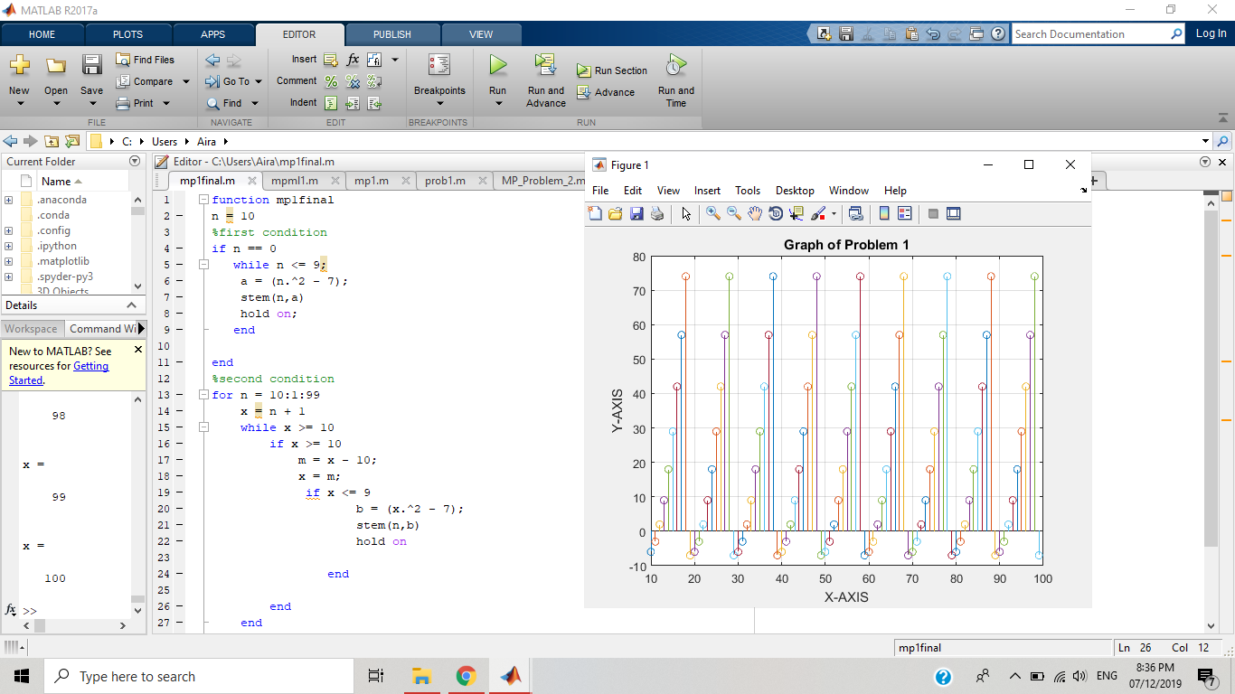

In the graph we used stem([Y](https://www.mathworks.com/help/matlab/ref/stem.html" \l "btrw_xi-1-Y))to plot the data sequence,Y, as stems that extend from a baseline along the x-axis. The data values are indicated by circles terminating each stem. From the given piecewise function the syntax should satisfy the condition of any value given from 0:199 to its respective operation using loop statements.